Task 1: CSS Basics
CSS (Cascading Style Sheets) is a stylesheet language used to describe the presentation of a document written in HTML or XML. CSS controls the layout of multiple web pages all at once and can define styles for elements such as colors, fonts, spacing, and positioning. Its primary role in web development is to enhance the visual appearance and user experience of web pages by separating content (HTML) from design (CSS).

Basic Structure of CSS
CSS is composed of rules that are applied to HTML elements. A rule consists of a selector and a declaration block:
- Selector: Specifies which HTML elements the styles will apply to (e.g., body, h1, p).
- Declaration Block: Contains one or more declarations enclosed in curly braces {}. Each declaration consists of a property and a value, separated by a colon :.

Example HTML Document with CSS
Here's a simple HTML document that includes a basic CSS stylesheet:
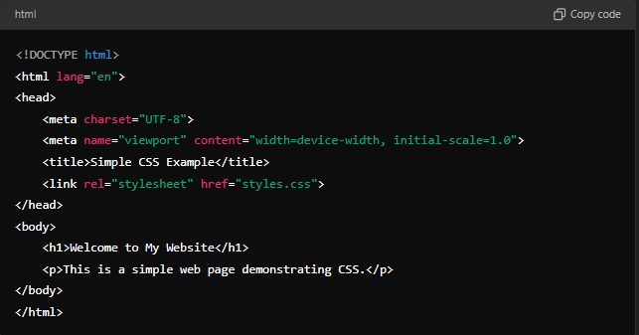
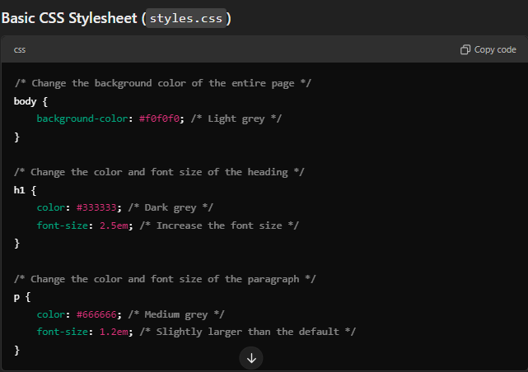

Explanation of the CSS Code
- Selector: body
  - Property: background-color: This sets the background color of the entire page. In this case, it is set to #f0f0f0, which is a light grey color. This affects the whole page's background.
- Selector: h1
  - Property: color: This defines the text color for all <h1> elements. Here, it is set to #333333, which is a dark grey color.
  - Property: font-size: This increases the font size of the heading to 2.5em. The em unit is relative to the font size of the parent element, making it responsive.
- Selector: p
  - Property: color: This changes the text color of all <p> (paragraph) elements to #666666, a medium grey.
  - Property: font-size: This sets the font size of the paragraph text to 1.2em, making it slightly larger than the default size.

Summary
In this example, CSS is used to create a visually appealing webpage by changing the background color, text color, and font sizes of various HTML elements. By utilizing CSS, developers can create a consistent look and feel across their website, improving the overall user experience.

